Sequence Selection for Multiple Alignments of

Transmembrane Proteins

Takuhiro Nishio*, Teruyuki Ohta**, Sunao Kaneko*** and Toshio Shimizu**

*Department of Integrated Human Sciences (Physics), Hamamatsu University School of Medicine,
Hamamatsu 431-3192, Japan

E-mail: nishio@hama-med.ac.jp

**Department of Electronic and Information System Engineering, Faculty of Science and Technology,
Hirosaki University, Hirosaki 036-8561, Japan

*** Department of Neuropsychiatry, School of Medicine, Hirosaki University, Hirosaki 036-8562, Japan

Abstract
An attempt of sequence selection is made for multiple alignments of transmembrane proteins in order to detect the structural similarity in the protein families. Treatment for the sequence selection, which is based on the pairwise sequence identities, is applied to ten sequence data sets of functional group of transmembrane proteins extracted from SWISS-PROT. The treatment excludes the sequences with low sequence identity from the divergent data sets effectively. Obtained multiple alignments are evaluated using two newly developed indices. The selected sequences, which are well aligned with few inserted gaps, seem to contain enough information for extracting the structural features of transmembrane functional groups.
Key Words: Multiple sequence alignment, Pairwise sequence identity, Sequence selection treatment, Transmembrane protein, Transmembrane segment

1. Introduction
Sequence alignments are required to find the structural information on the proteins of unknown structure. If satisfactory multiple alignments are achieved for transmembrane (TM) proteins, we may predict the TM topology and the functional similarity of the proteins with some transmembrane segments (TMSs) [1]. Indeed, a few interesting methods for multiple alignment of TM protein sequences have been proposed [2, 3]. However, sufficient multiple alignment in a conventional manner is difficult most likely because of diversities of the sequences in data sets. Sequence alignments and their analyses are dependent on the pairwise sequence identity in the data set. The twilight zone of 20–35 % sequence identity has been discussed [4, 5].
In the present study, we attempt a sequence selection as a pre-treatment for the multiple alignments of TM protein data sets. Our immediate aim is obtaining the aligned sequences with less inserted gaps combined with TM topology prediction. The procedure of the treatment is developed using the pairwise sequence identities. The treatment is carried out for ten sequence data sets of functional group of polytopic TM proteins extracted from SWISS-PROT. Two new indices are introduced for the evaluation of multiple sequence alignments of TM proteins: the degree of TMS position diversity, P, and the degree of gap insertion into TMS, G.
The treatment is effective in excluding the sequences with low sequence identity from the divergent data sets. If we can determine a suitable threshold value of sequence identity, the obtained data set seems to be worthwhile. The selected sequences must be valuable for extracting the structural features of polytopic TM functional groups. The properties of our sequence selection treatment and the resultant multiple alignments are discussed.

2. Materials and Methods
2.1 Data sets
Ten data sets of TM proteins are examined in this study (see Table 1). These contain the sequences of four 4-tms (acetylcholine receptor, GABA receptor, gap junction, and hydrogen ion transporter), two 6-tms (photosystem II and ABC transporter), and four 12-tms (solute carrier, amino acid transporter, sodium dependent transporter, and sugar transporter) protein groups. The data are extracted from SWISS-PROT Release 41.00 [6], according to its functional descriptions in DE, KW and/or CC lines [7]. All extracted sequences are full-length ones.
We focus on these 4-tms, 6-tms, and 12-tms protein groups, because they have a larger number of sequences than other ones registered in SWISS-PROT. These sequences were investigated first by the prediction of signal peptide region with DetecSig [8], and then by the TM topology prediction with ConPred II [9]. These predictions about the signal peptide and the number of TMSs are used for checking the SWISS-PROT descriptions. The length of TMS regions predicted by ConPred II is adjusted to 21 residues.

2.2 Sequence selection procedure
The method of sequence selection is efficiently carried out in the following two-step manner in order to make the pairwise sequence identities in the data set larger than a given threshold value. The sequence identities of all sequence pairs in the data set are calculated in advance. The pairwise sequence comparisons are performed using Clustal W 1.7 [10].
In the first step, sequence pairs in the data set are checked beginning at the pair with the lowest identity. If the identity of the pair is lower than the threshold, one sequence of the pair is kept and another sequence is temporarily discarded from the data set. The remaining sequence is chosen to have higher average identity to the other remaining sequences in the data set. This procedure is repeated for the pairs with higher sequence identity as long as the pairs with the identity lower than the threshold remain in the data set.
The second step is a comeback process. The sequences discarded temporarily in the first step are checked beginning at one with the highest average identity to all remaining sequences. If all identity values of the sequence to remaining ones are higher than the threshold, this sequence is replaced. This procedure is repeated for the discarded sequences as long as the sequences with an average identity higher than the threshold are detected.

2.3 Multiple alignments of TM protein and its evaluation
Multiple sequence alignments for the data sets of TM proteins are carried out using Clustal W 1.7 with the default parameter settings (gap opening penalty, 10.00: gap extension penalty, 0.20: substitution matrix, Gonnet series). The quality of the multiple alignments of TMS regions is examined with two indices: the degree of TMS position diversity, P and the degree of gap insertion into TMS, G.
The degree of TMS position diversity, P is represented by the standard deviation of center positions of TMS regions as follows:
$P=\sum_{i=1}^{m}{\left(\sqrt{\sum_{j=1}^{n}{{\left({\bar{p}}_{i}−p_{\text{ij}}\right)}^{2}}/n}\right)}/m$, (2.1)
where ${\bar{p}}_{i}$ is the average center position of i-th TMS of all sequences, and p_{ij} is the center position of the i-th TMS region (including inserted gaps) of sequence j. m and n are the number of TMSs in a sequence and the number of sequences in the data set, respectively.
The degree of gap insertion into TMS, G is the average number of gaps inserted into i-th TMS region over all sequences in the multiple alignments as follows:
$G=\sum_{i=1}^{m}{\left(\sum_{j=1}^{n}{g_{\text{ij}}}/n\right)}/m$, (2.2)
where g_{ij} is the number of gaps inserted into the i-th TMS region of sequence j.

3. Results and Discussion
3.1 Properties of the sequence selection
The qualities of the alignment of ten data sets are listed in Table 1 (‘before’ treatment columns). These examinations reveal the qualitative differences between the data sets.

Table 1. Qualities of the multiple alignments for ten data sets of TM protein sequences before and after the sequence selection treatment
Number of TMSs | Functional group | Before |  |  |  |  | after
Number of TMSs | Functional group | Minimun identity  (%) | Number of sequences | P | G |  | Minimun identity  (%) | Number of sequences | P | G
4 | Acetylcholine  receptor | 21.7 | 57 | 1.4 | 0.0 |  | _ | _ | _ | _
4 | GABA receptor | 24.9 | 38 | 1.3 | 0.2 |  | _ | _ | _ | _
4 | Gap junction | 5.8 | 70 | 5.5 | 0.3 |  | 17.6 | 58 | 1.6 | 0.1
4 | Hydrogen ion  transporter | 4.1 | 27 | 34.3 | 2.2 |  | 16.3 | 7 | 1.7 | 0.0
6 | Photosystem II | 19.4 | 23 | 1.3 | 0.5 |  | _ | _ | _ | _
6 | ABC transporter | 9.1 | 19 | 205.3 | 3.5 |  | 21.4 | 10 | 1.7 | 0.1
12 | Solute carrier | 8.0 | 29 | 53.3 | 5.2 |  | 21.7 | 15 | 2.1 | 0.5
12 | Amino acid  transporter | 9.5 | 35 | 6.5 | 1.4 |  | 23.2 | 8 | 2.0 | 0.3
12 | Sodium dependent  transporter | 8.6 | 39 | 16.9 | 1.3 |  | 30.9 | 35 | 1.9 | 0.0
12 | Sugar transporter | 6.5 | 66 | 22.0 | 3.2 |  | 22.3 | 16 | 2.0 | 0.1

Three data sets (acetylcholine receptor, GABA receptor, and photosystem II) have sufficiently high values of minimum sequence identity (around or above 20 %), and low values of P and G. In these cases, the data sets already have well ordered multiple alignments.
In the other seven data sets, there are many sequence pairs with identities lower than 20 % and relatively high P and G values. For example, the percentages of pairs with an identity lower than 20 % are 81.5 %, 59.6 % and 70.9 % within the data set of hydrogen ion transporter, ABC transporter and solute carrier, respectively. These are the targets of the following trials of sequence selection.
As shown in Fig. 1, the dependences of P and G indices on minimum pairwise identity are investigated. Both P and G decrease rapidly as the minimum identity increases up to around 20 %, and then level off for each group. Thus, we can assume the tentative minimum pairwise identity to be around 20 % for obtaining well-aligned sequences.

3.2 Improvements of multiple alignments by sequence selections
The results of multiple alignments after sequence selections are presented in Table 1 (‘after’ treatment columns). The minimum sequence identities around 20 % give small enough P and G values at the expense of fewer sequences as expected. In the case of sodium

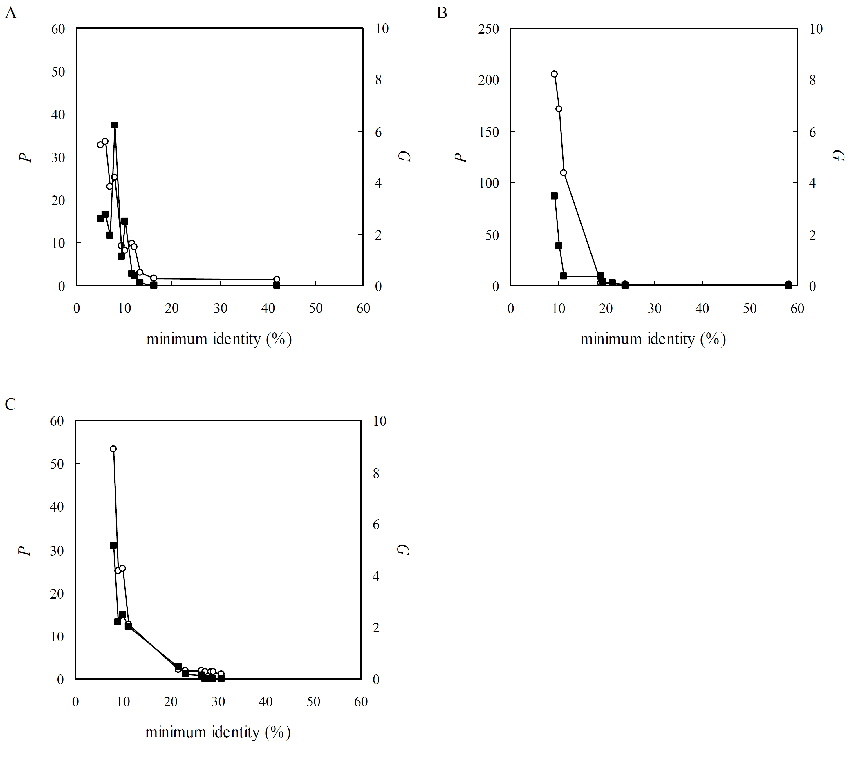
Fig. 1. The degree of TMS position diversity, P (open circle, left axis) and the degree of gap insertion, G (filled square, right axis) versus minimum pairwise sequence identity: A, hydrogen ion transporter; B, ABC transporter; C, solute carrier.

dependent transporter, there is no sequence pair whose identity is between 10.3 % and 30.9 % in the original data set.
In Fig. 2, the alignment results for four functional groups (A, hydrogen ion transporter; B, ABC transporter; C, solute carrier, and D, acetylcholine receptor) are shown with the color patterns of TM topologies. Except for acetylcholine receptor, the results before and after sequence selection are represented.
Before sequence selections, multiple alignments of three protein data sets frequently show a few stretched gaps in particular TMS regions. These gaps make TMS positions greatly dislocated. It looks as if gap insertion into the loop region, and not into the TMS region, helps to make the TMS regions well aligned. In the case of acetylcholine receptor, four TMS regions are well aligned without gaps, while many gaps are inserted in the loop regions.

Fig. 2. Schematic representation of the sequence multiple alignment results for four data sets (A, hydrogen ion transporter; B, ABC transporter; C, solute carrier, and D, acetylcholine receptor). The alignment results are shown both before and after the sequence selection, except for the acetylcholine receptor. Loop, TMS, and signal peptide regions are colored with red, green, and blue, respectively.

Due to the removal of these gaps by sequence selection, rather neat multiple alignments are achieved in each case (Fig. 2, A–C ‘after’). Even in these restricted number of successful alignments, we can observe that long loops (containing both tails) are generally length-variable and that short connecting loops are length-conservative. These observations seem consistent with the facts that functional or structural domains of TM proteins are on long loop regions [11, 12] and consecutive TMSs connected by short intervening loops can be regarded as a conserved structural unit [13].
We show a simple and reasonable way of improving multiple alignments for TM protein data sets by the pre-treatment of sequence selection at the expense of fewer sequences. In the process, the indices on the location of TMS and on the gap insertion are valuable as long as the TMS regions can be predicted correctly. We can assume that the selected proteins have high structural similarity to each other.
The sequence selection seems to be necessary in the preparation of the data set for the conventional multiple alignment at the present time. The sequence identity around 20 % seems to be significant in the comparison of TM protein sequences, although the number of examined data sets is not sufficient yet. The results, partly containing the sequences in twilight zone, on the sequence alignments of TM proteins merit further study. More examinations and refinements of the method are required.

4. Acknowledgments
This research was supported in part by a Grant-in-Aid for Scientific Research on Priority Areas (C) ‘Genome Information Science’ (No. 16014202) and a Grant-in-Aid for Scientific Research (S) (No. 16109006) from the Ministry of Education, Culture, Sports, Science, and Technology of Japan.

References
[1] Arai, M., Okumura, K., Satake, M. and Shimizu, T., Proteome-wide functional classification and identification of prokaryotic transmembrane proteins by transmembrane topology similarity comparison. Protein Sci., 13 (2004), 2170-2183.
[2] Saier, M. H., Jr., A Functional-Phylogenetic Classification System for Transmembrane Solute Transporters. Microbiol. Mol. Biol. Rev., 64 (2000), 354-411.
[3] Shafrir, Y. and Guy, R., STAM: simple Transmembrane Alignment Method. Bioinformatics, 20 (2004), 758-769.
[4] Rost, B., Twilight zone of protein sequence alignments. Protein Eng., 12 (1999), 85-94.
[5] Yang, A.-S. and Honig, B., An Integrated Approach to the Analysis and Modeling of Protein Sequences and Structures. II. On the Relationship between Sequence and Structural Similarity for Proteins that are Not Obviously Related in Sequence. J. Mol. Biol., 301 (2000), 679-689.
[6] Boeckmann, B., Bairoch, A., Apweiler, R., Blatter, M.-C., Estreicher, A., Gasteiger, E., Martin, M. J., Michoud, K., O'Donovan, C., Phan, I., Pilbout, S., and Schneider, M., The SWISS-PROT protein knowledgebase and its supplement TrEMBL in 2003. Nucleic Acids Res., 31 (2003), 365-370.
[7] Sugiyama, Y., Polulyakh, N. and Shimizu, T., Identification of transmembrane protein functions by binary topology patterns. Protein Eng., 16 (2003), 479-488.
[8] Lao, D. M. and Shimizu, T., A Method for Discriminating a Signal Peptide and a Putative 1st TM Segment. 2001 International Conference on Mathematics and Engineering Techniques in Medicine and Biological Sciences (METMBS '01). CSREA Press, Las Vegas, 2001, pp. 119-125.
[9] Arai, M., Mitsuke, H., Ikeda, M., Xia, J.-X., Kikuchi, T., Satake, M., and Shimizu, T., ConPred II: a consensus prediction method for obtained transmembrane topology models with high reliability. Nucleic Acids Res., 32 (2004), W390-W393.
[10] Thompson, J. D., Higgins, D. G. and Gibson, T. J., CLUSTAL W: improving the sensitivity of progressive multiple sequence alignment through sequence weighting, position-specific gap penalties and weight matrix choice. Nucleic Acids Res., 22 (1994), 4673-4680.
[11] Arai, M., Fukushi, T., Satake, M. and Shimizu, T., A proteome-wide analysis of domain architectures of prokaryotic single-spanning transmembrane proteins. Comput. Biol. Chem., 29 (2005), 379-387.
[12] Sonnhammer, E. L. L., Eddy, S. R. and Durbin, R., Pfam: A Comprehensive Database of Protein Domain Families Based on Seed Alignments. Proteins, 28 (1997), 405-420.
[13] Liu, Y., Gerstein, M. and Engelman, D. M., Transmembrane protein domains rarely use covalent domain recombination as an evolutionary mechanism. Proc. Natl. Acad. Sci. USA, 101 (2004), 3495-3497.

*Corresponding author: Takuhiro Nishio, Ph.D.
Department of Integrated Human Sciences (Physics),
Hamamatsu University School of Medicine,
1-20-1 Handayama, Higashi-ku, Hamamatsu 431-3192, Japan
E-mail: nishio@hama-med.ac.jp

